TAMIL NADU NATIONAL LAW UNIVERSITY
IN COLLABORATION WITH
NANI PALKHIWALA ARBITRATION CENTER, CHENNAI
1ST NATIONAL MEDIATION-ARBITRATION COMPETITION
8th-10th March, 2019
PROPOSITION
Premji Productions Ltd is a private company owned and run by Mr. Adnan Premji. The film production Co. started its business in the year 1950 with a small production unit. The Co. is currently considered to be one of the top production houses in Navalurisa with average revenue of $.5.6 billion per year. Navalurisa is a social, secular, republic and democratic country and its laws are in pari materia with that of India. Mr. Abhishek Arora, is a script writer by profession, and he approaches Mr. Premji with his recent manuscript. The manuscript focuses in and around the life of the Former Prime Minister (PM) of the country - Dr. Akshit Singh. The manuscript is largely influenced by the Dr. Akshit Singh’s life and involves stories from various real life incidents. Dr. Akshit Singh is a renowned economist, who had introduced various economic reforms in the country which very much aided in developing the financial status of the Country. He eventually ended up taking a political career and became the PM of Navalurisa. Mr. Premji was overwhelmed with the manuscript as he was an ardent supporter of the political party in which Dr. Akshit Singh belonged. Therefore, he decided to produce this particular film with the top most film cast and crew. In lieu of the same, a notice was sent to Dr. Akshit Singh informing him about the movie upon his life along with the original manuscript. Dr. Akshit Singh arranged for a special meeting with Mr. Premji and rest of the production crew along with Mr. Abhishek Arora for a discussion upon the same. In the meeting, Dr. Akshit Singh expressed his willingness to allow the production of movie with certain modifications. Certain scenes and plot changes were made accordingly. It was also decided that any further changes would be made only with his consent.
The cast selected included Mr. Carmel Fernadez, a well known cine actor and varied International and national award winner to perform the role of Dr. Akshit Singh. Premji Productions entered into contract with Manali Production, a sister company to produce the film and both of them joined hands with Navalurisa Fox Studios for making the movie. Furthermore, Mr. Dharma Ayyappan, a popular director and recent National award winner was selected to direct the movie. It is a motion picture with a huge cast and impressive production budget of $250 million after the tax. The official production of the movie started on 20.03.2017. The shooting of the movie was completed on 09.04.2018. The editing and rest of the activities were carried on till 10.09.2018. The distribution and marketing team did amazing advertisements and marketing with the first official teaser released on 01.07.2018, the date on which Dr. Akshit Singh was elected as the PM of the country almost 12 years back. The teaser itself received around 8.2 million views around the world. A month later, the first trailer was released on 11.10.2018, the date on which Dr. Akshit Singh had introduced the revolutionary five year economic reforms. This received around 2.3 millions view on the first day itself across the globe. However, on the very next day i.e.12.10.2018, Premji Productions Ltd received a legal notice from the Navalurisa People’s Party (NPP) seeking them to take down the teaser and the trailer of their new movie as soon as possible. The contents of the legal notice are submitted as Exhibit 1. The legal notice further indicated that if the movie was released in the market, NPP would proceed legally and take necessary actions against the production house.
Soon after, there was a quick meeting conducted among the interested parties including Mr. Premji, Mr. Abhishek Arora and Mr. Dharma Ayyappan and they decided to take down the full video from all the social media to avoid any legal action as a temporary redress. Hence a request for the same was made to the website - ‘View Trender’ and such other social media like Netflix, Face book, Twitter, including various national and international channels etc. View Trender ltd. Co. (VT) is one of the largest website hosting millions of videos. VT alone has invested shares worth 200 million dollars globally. VT took off all the videos related to movie including the official teaser and trailer. Moreover, all other social media platforms were also requested to do the same. There were more than 50 videos alone in VT made by various freelancers and paid VT users describing various matters upon the teaser, trailers and on the life of Dr. Akshit Singh including parody videos. As soon as the videos were taken down, there were hundreds of comments seeking a right to view these videos as it’s about their former PM. Moreover, social media pages like Facebook and Twitter were filled with comments and tweets upon the same protesting the video to be back online and mocking its sudden take down.
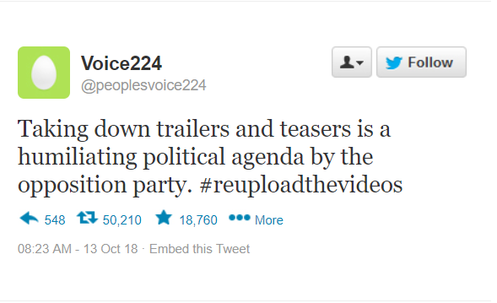
The posts related to the same were highly trending and in defense, the opposition parties made various tweets and comments mocking the take down of the video.
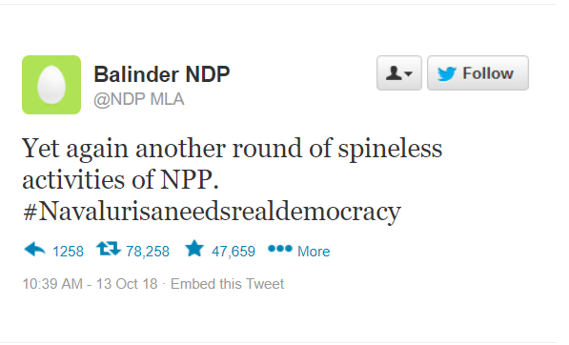
These opposing statements raised a demand among the public to put these videos back into VT and such other social media platforms. This pressing issue came for discussion before the “Navalurisan Entertainment Guild” popularly called as NEG, an association for protecting the interests of online social media platforms working in Navalurisa. In furtherance of these recurrent demands, NEG decided to release a press note saying that it’s on the “Request and a Reasoned decision for the general welfare” that the videos has been taken down. This press note triggered more pressing demands for the videos to be uploaded back. These demands from the public raised a huge problem to NPP in devising its agenda for the upcoming election. Moreover, the controversy led to the downfall of the shares to various online social media platforms, especially VT suffered a lot being the largest player in the field. Its share almost fell down to 49%. However, NPP was very strong that it’s their right to decide the movie’s release. In all these issues, Dr. Akshit Singh even though willing to release the movie, was strongly ordered by NPP not to do so predicting it as a self pricking act to his own political career. Dr. Akshit Singh was selected as the prospective candidate by NPP for their upcoming elections.
The whole issue demanded the Navalurisan Parliament to look into the matter. Therefore, taking the matter for special enquiry by the Special Enquiry Committee, Mr. Premji and Mr. Amjith Zakir, the current CEO of VT, Mr. Khush Rastogi, the chairperson for the NEG and two other prominent figures from other online social media were called for giving testimonies. The whole proceedings were telecasted on the national and international TV channels and other such social media platforms. During the proceedings, various members asked specific questions especially to Mr. Amjith Zakir and Mr. Khush Rastogi related to VT’s privacy policy and future impacts of using such technologies in the entertainment industry which violated their right to personal choice. The Members of Navalurisan Parliament alleged that even though the take down of the video is a personal choice, however there is no assurance that all the data is indeed secured and not sold. This is therefore, a serious outrage to the privacy issues of the internet consumers. The excerpts from the transcript of this enquiry are submitted as Exhibit 2. This enquiry procedure was totally mocked on various social media platforms as a “face palm on tech savvy”.

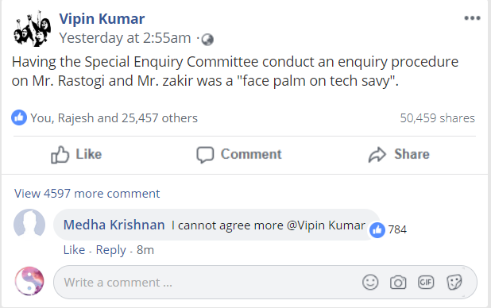
After the enquiry, Navalurisan Parliament adjourned the discussion for its next session. However, Mr. Zakir was hugely affected by this enquiry which he found to be humiliating. He felt that calling him for enquiry was like a mockery of his Company and his expertise in the area and in general the entertainment industry. However, he blamed that every problem was due to Premji Productions Ltd’s movie release. Therefore, he sent a legal notice to Mr. Premji and Dr. Akshit Singh who is the member of NPP seeking to compensate him for his reputational damage. Conversely the lawyer for Premji Productions Ltd. replied seeking an alternative dispute resolution so that the matter can be solved more amicably. Therefore, Mr. Zakir , Mr. Premji and Dr. Akshit Singh entered into a Med-Arb agreement to resolve their difference of opinions and claimed compensation with regard to the alleged defamation which can be found in Exhibit 3.

Note: The Proposition is drafted by Drafting Committee consisting of - Mrs. S. Deepika, Assistant Professor and Faculty Advisor of ADRC, Ms. Ayushi Parashar, 5th year B.Com. LL.B. (Hons.) and Mr. Hari Vignesh, 5th year B.Com. LL.B. (Hons.), TNNLU. We acknowledge and express our gratitude towards- Ms. Apoorvi Shrivastava, Assistant Professor, IIFM Law School, Bengaluru and Ms. Aparna Asokan, Assistant Professor, TNNLU for reviewing the proposition. Also , a special mention to Mr. Ravindran, 4th year B.A. LL.B. (Hons.) and Ms. Mrinali Dave, 1^{sh} year B.Com. LL.B. (Hons.), TNNLU for their timely assistance.

